**SW Engineering CSC648/848 Section 01 Spring 2018**

**PARSE**

Pollution and Accident Reporting for a Safer Environment

**Milestone 4**

May 17th, 2018

**Team 04**

Rodrigo Bell, Team Lead (rbell594@gmail.com)

Charlie Tuttle

Rohan Patel

Dion Matthew Lagos

Kamran Khadivi-Dimbali

Michael Schwiebs

Zhenru Huang

**Table of Contents**

**Product Summary . . . . . . . . . . . . . . . . . . . . . . . . . . . . . . 3**

**Usability Test Plan . . . . . . . . . . . . . . . . . . . . . . . . . . . . . . 4**

**QA Test Plan . . . . . . . . . . . . . . . . . . . . . . . . . . . . . . . . 6**

**Code Review . . . . . . . . . . . . . . . . . . . . . . . . . . . . . . . . . 8**

**Self-check: Security . . . . . . . . . . . . . . . . . . . . . . . . . . . . . 10**

**Self-check: Non-functional Requirements . . . . . . . . . . . . . . . . . . . . 11**

**Product Summary**

PARSE is a web application that strives to be a simple to use listing platform for local environmental issues. With PARSE, people can easily check for environmental issue wherever they go in the city.

PARSE provides a simple and easy to use set of features:

* All guests can view environmental issues right from the PARSE home page
* Anyone can easily search for issues by typing in a zipcode or category in the search bar.
* Issues provide plentiful information and images with Google Maps integration.
* City managers have access to a simple to use dashboard making it simple to set the issue status.
* Explore the PARSE web application at: csc648-team04.herokuapp.com

**Usability Test Plan**

**Test Objective**

* The objective of this test is to gauge the usability of the site’s main function: Search.
* Expose flaws with the Search function by asking our testers to perform the search task with no prior instructions. The testers will need to intuit how to use the Search function in order to search for the targeted queries.

**Test Plan**

**System setup**

* Tester will log into a computer with access to the internet and access to the following accepted internet browsers: Google chrome or Firefox.

**Starting point**

* Tester will begin at the site homepage wherein a search button will be present.

**Task to be accomplished**

* Tester will attempt a search for listings in a city of their choosing.
* Tester will attempt a search for listings with a zip code of their choosing.

**Intended Users**

* The targeted user is broad, as any person who is searching for a property is a potential customer.
* Users will be assumed to have no technical expertise and may be a complete novice to web browsing.

**Completion criteria**

* Tester is satisfied that they have accomplished the search query they attempted. This is evaluated from a post test questionnaire.

**Usability** **Questionnaire**

**I found the Search function easy to use (Check one)**

**__** Strongly Disagree __ Disagree __ Neither Agree or disagree __ Agree __ Strongly Agree

**I found the listings for the Categary I was searching for (Check one)**

**__** Strongly Disagree __ Disagree __ Neither Agree or disagree __ Agree __ Strongly Agree

**I found the listings for the zip code I was searching for (Check one)**

**__** Strongly Disagree __ Disagree __ Neither Agree or disagree __ Agree __ Strongly Agree

**Comments:**

**QA Test Plan**

**Test Objective**

1. The objective of this test is to validate the functioning of one of the primary features of the website, i.e. Search.
2. The tester shall be given specific instructions to follow and the results shall be recorded as a PASS/FAIL in each of the individual cases.

**Hardware and Software setup**

1. The tester should have access to a device that supports recent versions of two web browsers – Google Chrome and Mozilla Firefox.
2. The devices used should be connected to internet via Wi-Fi, Ethernet, Cellular, etc.
3. The internet connection speed should be adequate (at least 2.5MBps) for flawless browsing experience.
4. And finally, the user should open the following link on either of the prescribed browsers to begin the test.

**Features to be tested**

This test will solely focus on the Search feature of the website. The Search feature shall be operated by inputting a query in the search field on the very top of the homepage of the website. The permitted inputs are names of cities or the zip-codes.

|  |  |  |  |  |  |  |
| --- | --- | --- | --- | --- | --- | --- |
| **Test #** | **Test title** | **Description** | **Test input** | **Expected output** | **Result (Chrome)** | **Result (Firefox)** |
| 1. | Zip-code search | Tester shall input the prescribed zip-code number into the search bar and the results shall be validated through comparison with the expected output. | 94112 | 1 result | PASS | PASS |
| 2. | Category search | Tester shall input the prescribed name of city into the search bar and the results shall be validated through comparison with the expected output. | “Accident” category selected | 3 results | PASS | PASS |
| 3. | Zip-code and category search | Tester shall input the prescribed zip-code and issue category in the search bar and the results shall be validated through comparison with the expected output | 94112 with “Pollution” category selected | 1 result | PASS | PASS |

**Code Review**

A code review was conducted on the basic implementation the Node.js app entry point. Specifically, this code review shows the code to setup our MySql connection to the database.

In order to ensure clear code, indentation styles is used with 4 spaces for indentation.

**Feature:** Database setup

**Submitted by:** Rodrigo Bell

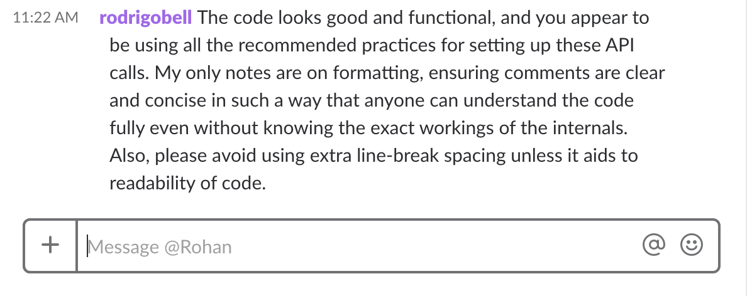

/app.js

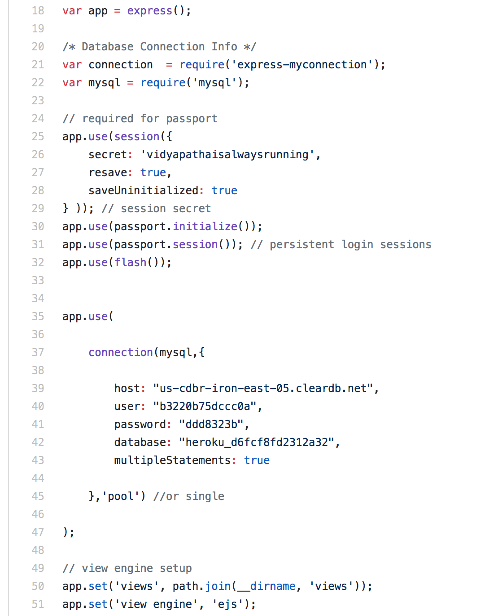

**Self-check: Security**

**Major Assets Being Protected**

* Name
* Username
* Password

**Passwords**

Passwords are hashed, and no plain-text passwords are stored in the database.

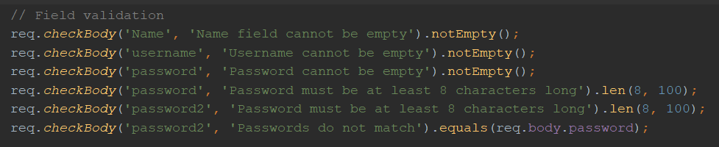

**Self-check: Non-functional Requirements**

|  |  |  |
| --- | --- | --- |
| 1 | Application shall be developed and deployed using SW stack approved by class CTO Anthony Souza. | DONE |
| 2 | Application shall be hosted and deployed on Heroku as approved by Anthony. | DONE |
| 3 | Application shall be optimized for standard desktop/laptop browsers, i.e., must render correctly on the latest versions of all major browsers: Chrome, Safari, Mozilla | DONE |
| 4 | Application shall have responsive UI code so it can be adequately rendered on mobile devices but no mobile app is to be developed. | DONE |
| 5 | Data shall be stored in the MySQL database on the server in the team's Heroku account. | DONE |
| 6 | Maps showing location of the environmental issue shall be provided. | DONE |
| 7 | No more than 50 concurrent users shall be accessing the application at any time. | DONE |
| 8 | Privacy of users shall be protected and all privacy policies will be appropriately communicated to the users. | ON-TRACK |
| 9 | The language used shall be English. | DONE |
| 10 | Application shall be very easy to use and intuitive. No prior training shall be required to use the website. | DONE |
| 11 | Google analytics shall be added. | DONE |
| 12 | Site security: basic best practices shall be applied (as covered in the class). | ON-TRACK |
| 13 | Modern SE processes and practices shall be used as specified in the class, including collaborative and continuous SW development. | DONE |